Appendix 1 – Site Plan
20/00182/VAR – Oxford Railway Station
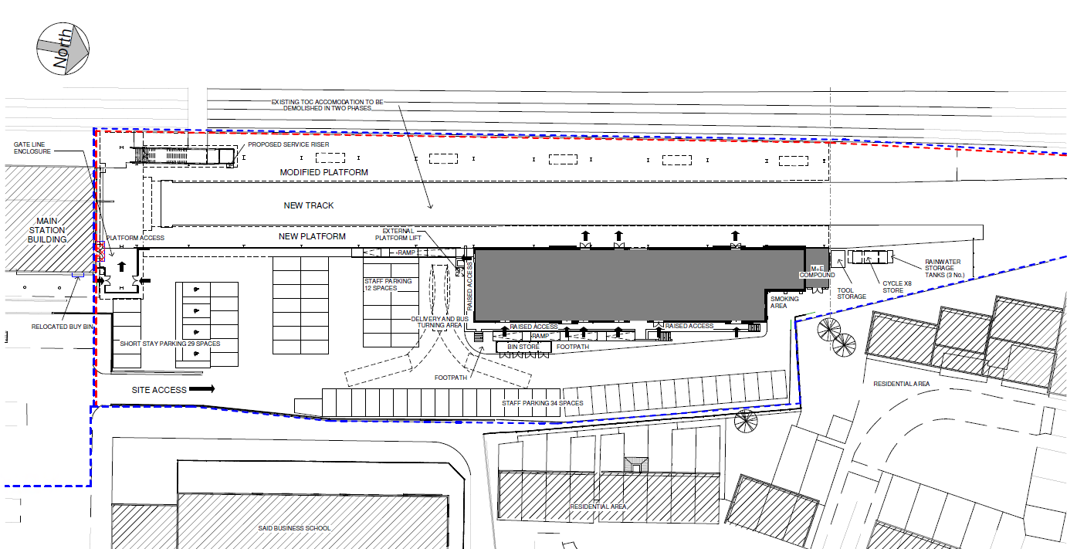
Rewley Road
Stable Close

